Specialized Terminology

What is Specialized Terminology
# Source: AI Source: Provided by: [Data Path: Persons Table -> ID Column: 1, Name_En Column: Motasem Essam] -> From: [Chatgpt (GPT-4-turbo)] on [7/31/2025]
Specialized terminology refers to vocabulary that is unique to a particular profession, discipline, or field of study, and is not typically used or understood by the general public without background knowledge.

✅ Key Features:
# Source: AI Source: Provided by: [Data Path: Persons Table -> ID Column: 1, Name_En Column: Motasem Essam] -> From: [Chatgpt (GPT-4-turbo)] on [7/31/2025]
- Highly domain-specific (e.g., legal, medical, linguistic, technological)
- Requires expertise or training to understand and use correctly
- Often includes technical jargon and precise definitions
- Helps ensure accuracy and efficiency in expert communication

📚 Examples:
# Source: AI Source: Provided by: [Data Path: Persons Table -> ID Column: 1, Name_En Column: Motasem Essam] -> From: [Chatgpt (GPT-4-turbo)] on [7/31/2025]
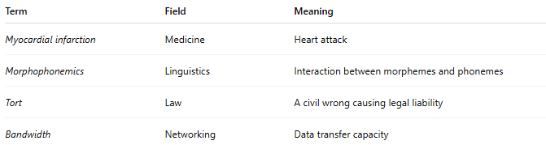
Term | Field | Meaning
Myocardial infarction | Medicine | Heart attack
Morphophonemics | Linguistics | Interaction between morphemes and phonemes
Tort | Law | A civil wrong causing legal liability
Bandwidth | Networking | Data transfer capacity

👥 Primary Users:
# Source: AI Source: Provided by: [Data Path: Persons Table -> ID Column: 1, Name_En Column: Motasem Essam] -> From: [Chatgpt (GPT-4-turbo)] on [7/31/2025]
- Experts and professionals
- Researchers and scholars
- Students in advanced or technical education
- Translators and terminologists

Specialized terminology vs Field-Specific Terminology

🔍 Comparison Table:
# Source: AI Source: Provided by: [Data Path: Persons Table -> ID Column: 1, Name_En Column: Motasem Essam] -> From: [Chatgpt (GPT-4-turbo)] on [7/31/2025]
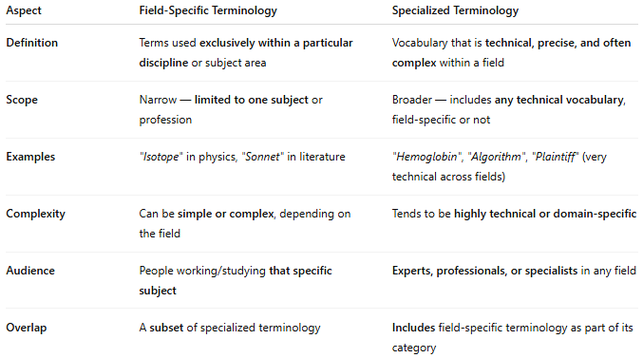

Aspect | Field-Specific Terminology | Specialized Terminology
Definition | Terms used exclusively within a particular discipline or subject area | Vocabulary that is technical, precise, and often complex within a field
Scope | Narrow — limited to one subject or profession | Broader — includes any technical vocabulary, field-specific or not
Examples | "Isotope" in physics, "Sonnet" in literature | "Hemoglobin", "Algorithm", "Plaintiff" (very technical across fields)
Complexity | Can be simple or complex, depending on the field | Tends to be highly technical or domain-specific
Audience | People working/studying that specific subject | Experts, professionals, or specialists in any field
Overlap | A subset of specialized terminology | Includes field-specific terminology as part of its category

🧠 Key Distinction:
# Source: AI Source: Provided by: [Data Path: Persons Table -> ID Column: 1, Name_En Column: Motasem Essam] -> From: [Chatgpt (GPT-4-turbo)] on [7/31/2025]
- Field-Specific Terminology is limited to one subject (e.g., legal, medical).
- Specialized Terminology is a broader category that includes:
  - Field-specific terms
  - General technical terms
  - Jargon used in specialized contexts

✅ Example to Illustrate:
# Source: AI Source: Provided by: [Data Path: Persons Table -> ID Column: 1, Name_En Column: Motasem Essam] -> From: [Chatgpt (GPT-4-turbo)] on [7/31/2025]
- Field-Specific Term:
→ “Sonnet” — only relevant in literature.
- Specialized Term:
→ “Cognitive load” — a technical term used in education, psychology, and UX design.

